LAB 12
Firebase Database Setup & Implementation Step 1: Firebase Setup (Configuration):
Packages
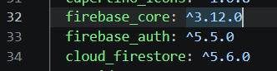
Configuration
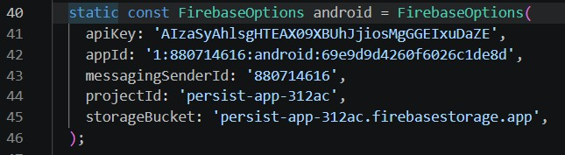
Initialization:
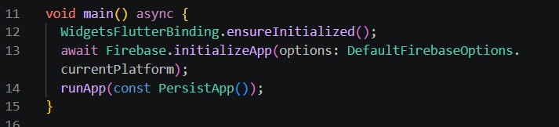

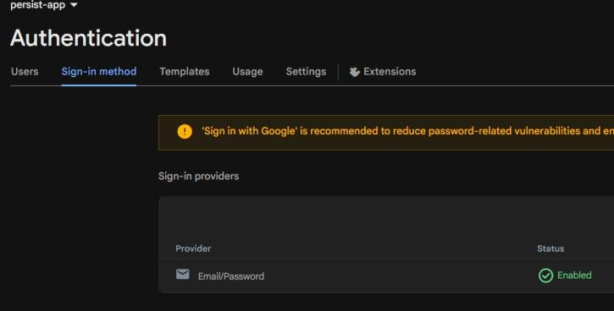
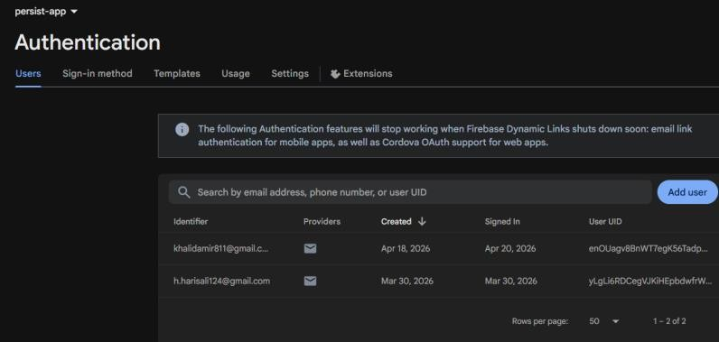

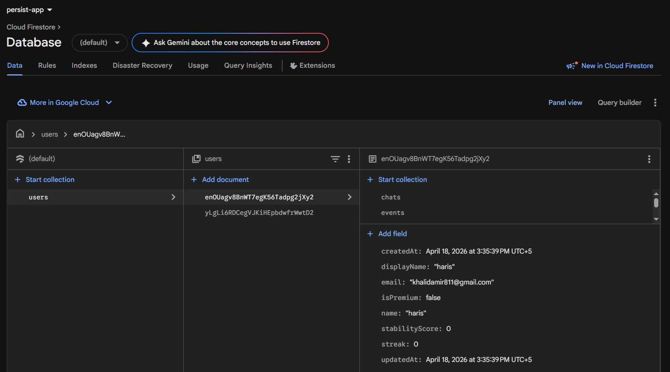

PHASE 2 — Fire store Data Models
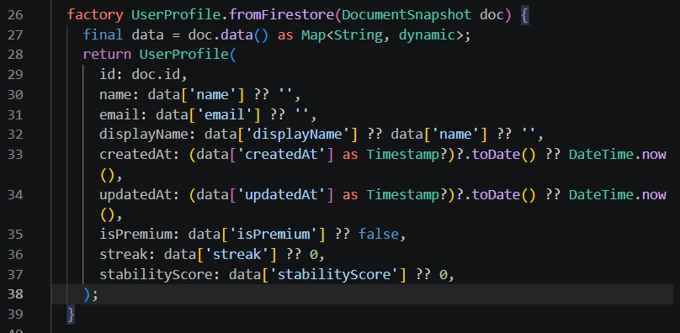
User Profile

Explain: As already logged in when opening the app the load sign sjows firbase read and let you logged in on the spot.

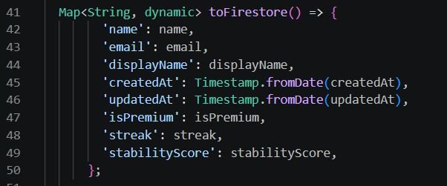
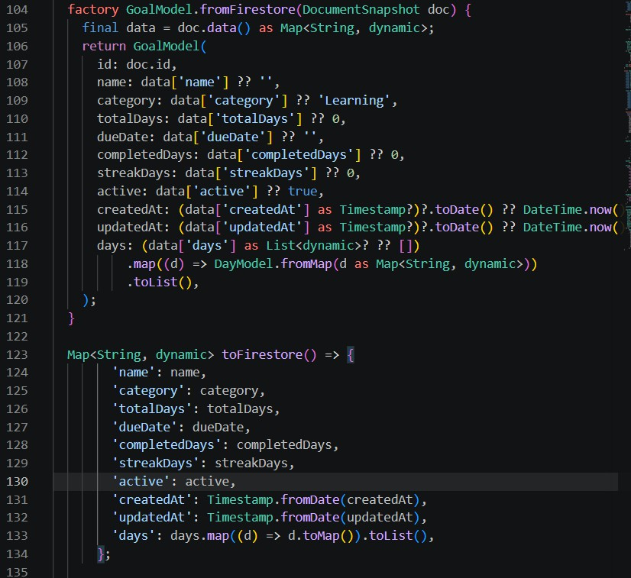
Goal Model:

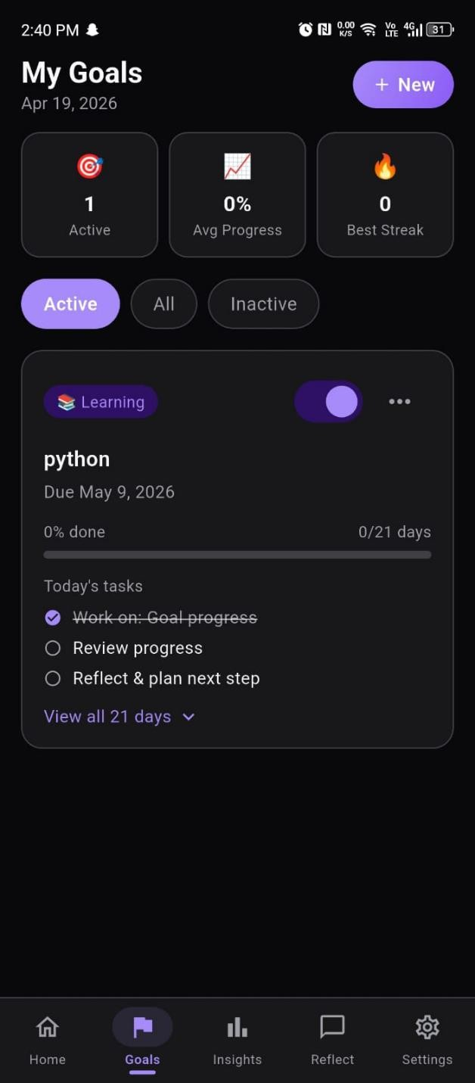

Tasks complete

